Disaster Risk Management System
Architecture of RESQGUIDE:
Layers included:
- Frontend (React + UI Pages)
  - Login
  - Register
  - Building Details Form
  - Safety Measures
  - Risk Result
  - Alerts & Safe Places
- Backend (Node.js + Express)
  - Authentication (JWT)
  - Password Hashing
  - Rule-based Risk Evaluation
  - API Handling
- Databases
  - PostgreSQL
    - Users
    - Buildings
    - Safety Measures
    - Risk Assessment
  - MongoDB
    - Disaster Alerts
    - Safety Instructions
    - Safe Places

4.External APIs
Weather / Disaster API
  - Google Maps API
Flow:
• User submits building and safety data
• Backend evaluates risk using predefined rules
• Weather API triggers disaster alerts
• Google Maps API identifies nearest safe places
• Results displayed to user in real time.

PostgreSQL :
users TABLE:
Column Name | Data Type | Key / Constraint | Example Value
user_id | SERIAL | Primary Key | 101
name | VARCHAR(100) | NOT NULL | Ravi Kumar
email | VARCHAR(150) | UNIQUE | ravi@gmail.com
password_hash | TEXT | NOT NULL | $2b$10$abc123
role | VARCHAR(20) | DEFAULT user | admin
created_at | TIMESTAMP | Auto Generated | 2026-01-26

buildings TABLE:
Column Name | Data Type | Key / Constraint | Example Value
building_id | SERIAL | Primary Key | 201
user_id | INTEGER | Foreign Key | 101
building_type | VARCHAR(50) | NOT NULL | Factory
floors | INTEGER | NOT NULL | 4
construction_year | INTEGER | NOT NULL | 2015
latitude | DECIMAL(9,6) | NOT NULL | 16.306700
longitude | DECIMAL(9,6) | NOT NULL | 80.436500
created_at | TIMESTAMP | Auto Generated | 2026-01-26

safety_measures TABLE:
Column Name | Data Type | Key / Constraint | Example Value
safety_id | SERIAL | Primary Key | 301
building_id | INTEGER | Foreign Key | 201
fire_extinguisher | BOOLEAN | Default FALSE | TRUE
emergency_exit | BOOLEAN | Default FALSE | TRUE
cctv | BOOLEAN | Default FALSE | FALSE
medical_kit | BOOLEAN | Default FALSE | TRUE
structural_strength | VARCHAR(20) | NOT NULL | High

Risk_assessment TABLE:
Column Name | Data Type | Key / Constraint | Example Value
risk_id | SERIAL | Primary Key | 401
building_id | INTEGER | Foreign Key | 201
risk_score | INTEGER | NOT NULL | 68
risk_level | VARCHAR(20) | NOT NULL | High
assessment_date | TIMESTAMP | Auto Generated | 2026-01-26

MongoDB :
disaster_alerts COLLECTION:
Field Name | Data Type | Description | Example Value
_id | ObjectId | Unique document ID | 65af12…
disaster_type | String | Type of disaster | Flood
severity | String | Alert level | High
location | String | Affected area | Guntur
alert_message | String | Alert text | Flood warning issued
timestamp | Date | Alert time | 2026-01-26

safety_recommendations collection:
Field Name | Data Type | Description | Example Value
_id | ObjectId | Unique document ID | 65af23…
disaster_type | String | Disaster category | Flood
risk_level | String | Risk severity | High
instructions | Array | Safety steps | Move to higher ground
last_updated | Date | Update time | 2026-01-26

safe_places collection:
Field Name | Data Type | Description | Example Value
_id | ObjectId | Unique document ID | 65af34…
place_name | String | Safe location name | Govt High School
place_type | String | Shelter type | School
latitude | Number | Latitude | 16.308900
longitude | Number | Longitude | 80.439800
capacity | Number | Max people | 500
supported_disasters | Array | Disaster types | Flood, Cyclone

Security tokens:
JWT Token authentication:
Token Flow in ResGuide:
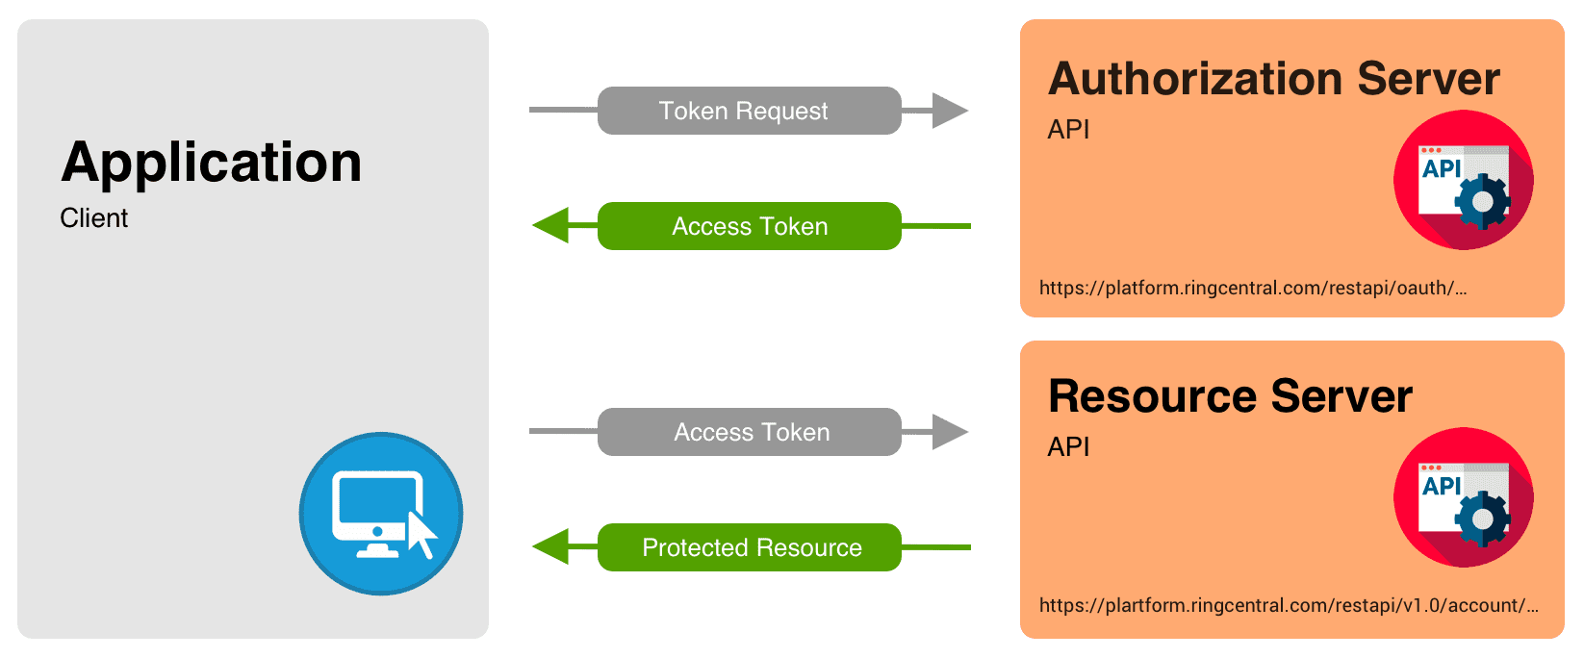

Password Hashing:
